General Chemistry 2 Quarter 1 Week 3

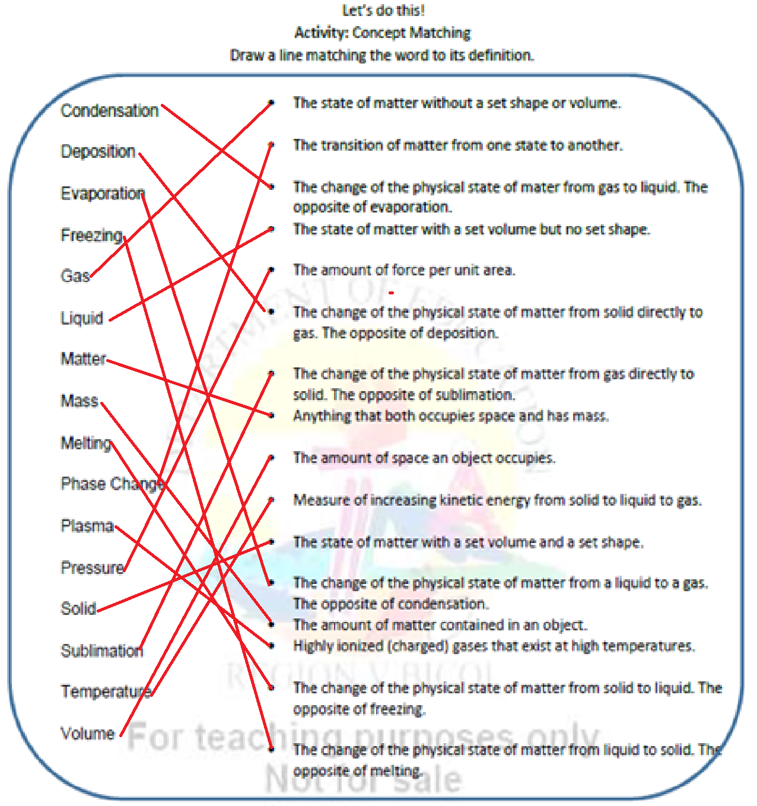Millano, Rei Benedict L. 12-Laplace 9-6-2022

**Monday**

Pre-Test:

1. A 2. C 3. A 4. A 5. C

Elicit:

1. Sublimation
2. Deposition
3. Melting
4. Freezing
5. Vaporization
6. Condensation

Focus Questions:

1. Because when C02 is frozen solid (Dry Ice) according to its phase diagram the needed earth atmospheric pressure is many times much higher along the regular temperature range making it succumb to sublimation.
2. Although pressure is factor of what phase of matter is and could be usually lowering the temperature turns it into solid when theoretically reaching absolute cold. For Propane it mostly needed below 2 times freezing point of water.

Post-Test:

1. B 2. A 3. C 4. B 5. A

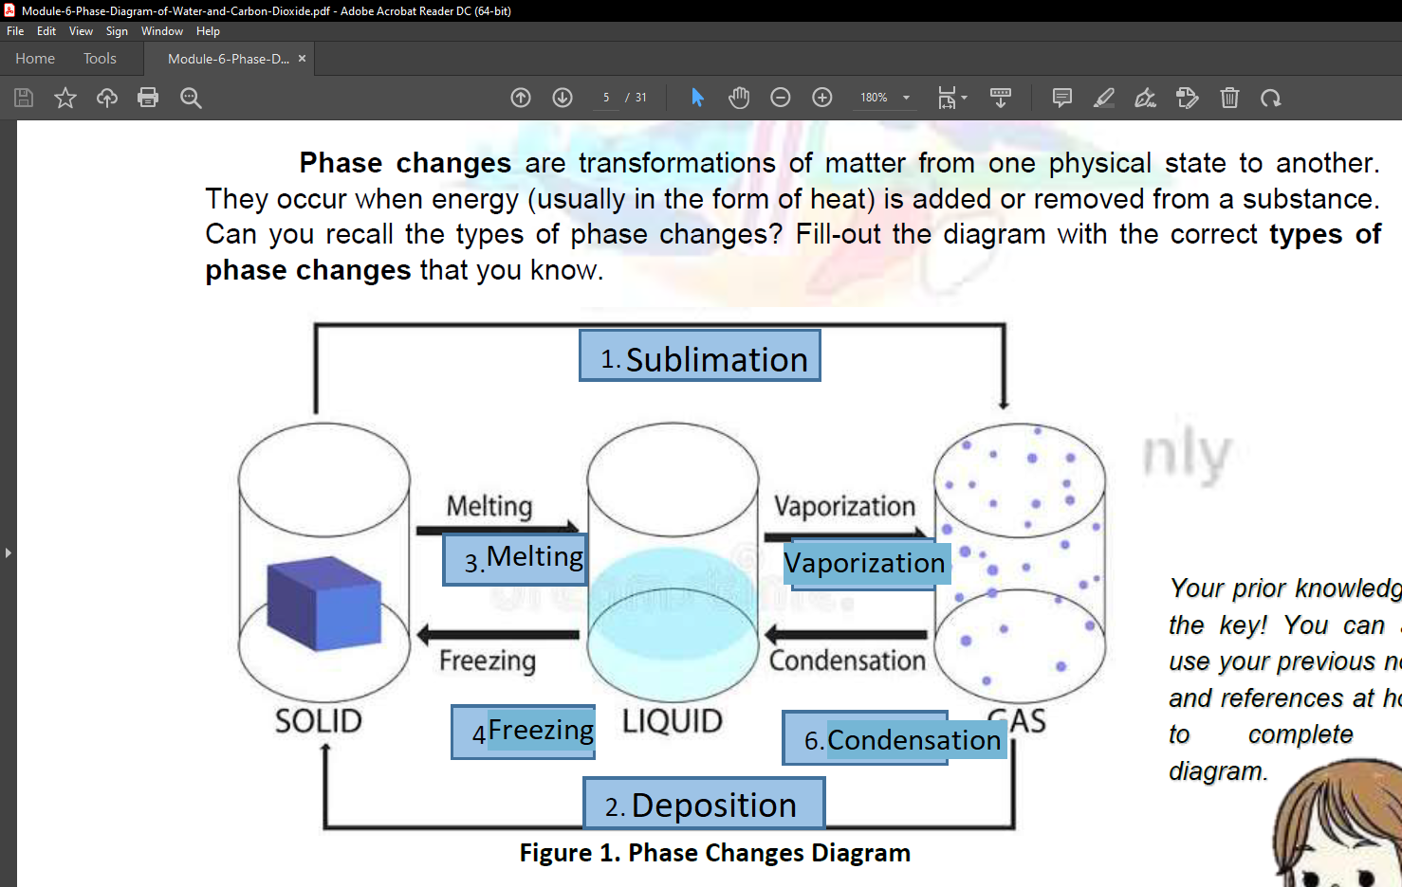**Tuesday**

Elicit:

1. Sublimation
2. Deposition
3. Melting
4. Freezing
5. Vaporization
6. Condensation